
PSA CORPORATION LIMITED
On-the-Job Training (OJT) Booklet

Trainee Details
JOB TITLE
YARD SHIFTING SUPERVISOR

Name: | ________________________
Employee Number: | ________________________
Department: | ________________________
Course Start Date: | ________________________
Course End Date: | ________________________

MODULE
YARD SHIFTING SUPERVISOR COURSE

Document Control
YARD SHIFTING SUPERVISOR |  | Handout Ref No.:
Action | Name | Date
Drafted by:
Vetted by:
Approved by:

© PSA Corporation Limited. Year 2015. Printed in Singapore. All rights reserved. Please note that information contained in these training materials are strictly confidential and may not be revealed to any third parties, reproduced, stored in a retrieval system nor transmitted in any form or by any means (electronic, mechanical, photocopying, recording, or otherwise) without the prior written consent of PSA Corporation Limited.

INTRODUCTION
This OJT program is designed to equip you with the operational expertise and safety competencies required as a Yard Shifting Supervisor in YOD. By completing this training, you will master operational and safety competencies critical to our yard operations.
Use this booklet as your daily reference guide during the 4-week program.

TRAINING OBJECTIVES
Upon successful completion of this program, you will be competent to:
- Execute Deployment Verification
  - Conduct pre-shift checks of equipment and personnel deployment
  - Check for current CMRs available for the shift and Point Group Allocations
- Develop Shifting Plans
  - Create optimized work plans based on:
    - Available CMR/PM resources
    - Operational urgency priorities
    - Vessel cut-off timelines
- Maximize Yard Productivity
  - Strategically allocate PM resources to:
    - Achieve IYS performance targets such as IYS wait time and Productivity levels which contributes to overall Yard KPIs
    - Minimize empty trips where possible to increase operational efficiency
    - Efficiently resolve overstows and long hauls
- Maintain Safety Compliance
  - Implement all PSA safety protocols during:
    - Equipment operations
    - Fatigue management of PM drivers
    - Personnel movements

ON-THE-JOB TRAINING (OJT) CURRICULUM
JOB TITLE:  Yard Shifting Supervisor |  | SECTION:  P1-3
DEPARTMENT:  Yard Operations (YOD) |  | DIVISION:  SE1
OJT MODULE:  Yard Shifting Supervisor Course |  | TOTAL TASKS: | TOTAL OJT HOURS:
S/N | TASKS |  | OJT HOURS
1 | Use of Systems - (CITOS, YOMC, PORTNET, YCS, SHUFFLING, CCTV) for Operations |  | 2 days
2 | Identify Yard Layout and Equipments used across P1-3 |  | 2 days
3 | Deployment & Resource Verification |  | 2 days
4 | CMRs, Point Group & PM allocation |  | 7 days
5 | Monitor Yard Operations and PM optimization |  | 7 days
6 | Handle and Escalate different Yard Exceptions |  | 1 day
7 | YPD attachment |  | 7 days

MODULE 1 – USE OF SYSTEMS
Task | Tasks To Do | Task Objectives/Standard to Meet | Skills & Knowledge Explained | Checklist
CITOS/  PORTNET | BERTH Chart  ENQC  YMCN  Container Journal  DG PM4 | BERTH Chart – Monitor vessel berthing schedules.  ENQC – Verify container details and status.  YMCN – View container history.  Container Journal – Record of container details.  DG PM4 – View dangerous goods documentation. | - Navigating CITOS/PORTNET interface.  - Understanding container codes and statuses | - Successfully accessed BERTH Chart.  - Performed ENQC for container verification.  - Updated YMCN for yard movements.  - Maintained Container Journal accurately.  Processed DG PM4 correctly.
CCTV | OpsVdi Access | Log in and monitor CCTV feeds.  Ensure real-time surveillance of operational areas.  Report any anomalies | - Operating OpsVdi software.  - Navigate CCTV for EARTG, OHBC, etc | - Successfully logged into OpsVdi.  - Access to various equipments & yard locations
YCS/  SHUFFLING | Shuffling Panel  IYS Shifting Panel | Shuffling Panel – Manage container reshuffling.  IYS Shifting Panel – Manage internal shiftings, shuffling and generate reports | - Optimize container via row shuffling & side shuffling  - Formulate a shifting plan | - Efficient use of shuffling tools for RTG/BC/FM  - Suspend, schedule, sequence CMRs into different point groups  - Generate reports
YOMC | YOMC Panel  MB Panel  Diversion Panel  PM Monitoring | YOMC Panel – Oversee yard operations.  MB Panel – Monitor mealbreak activities.  Diversion Panel – Handle container diversions.  PM Monitoring – Track performance metrics. | - Toggle between all terminal /section  - MB/WT in real-time as operators go on/off break  - Double-check container details before approving DG diversions  - Update container location  - PM no-show monitoring | - Proficient use of YOMC interface  - Monitor WT/MB/CSB compliance (max 30 min include marshalling)  - Able to handle diversion, DG diversion, update job location  - Able to monitor PM productivity, no-show and location

MODULE 2 – IDENTIFY YARD LAYOUT & EQUIPMENTS USED ACROSS P1-3
Task | Tasks To Do | Task Objectives/Standard to Meet | Skills & Knowledge Explained | Checklist
SCANNING LOCATION | Email  Location  Procedure  Contact Number | Email – Check and respond to scanning-related emails.  Location – Identify scanning zones in P1-P3.  Procedure – Follow the correct scanning process.  Contact Number – Know whom to call for scanning issues. | - Ensure accurate and timely scanning of containers.  - Follow up and closing email loop | - Properly checked and responded to scanning emails.  - Located and scanned containers in the correct area  - Followed the scanning procedure accurately.  - Used the correct contact number for support.
DOOR TURN/BUND AREA/JAMMED CONE | Respective Location – Identify and manage:  Door Turn Areas (container entry/exit points).  Bund Areas (spill containment zones).  Jammed Cones Area | Ensure smooth container movement.  Prevent spills and hazards in bund areas.  Quickly resolve jammed cone situations. | - Safety procedures for bund areas.  - Troubleshooting jammed equipment. | - Located door turn, bund, and jammed cone areas.  - Followed safety protocols in bund areas.  - Reported and resolved jammed cone issues.
P1-6 LAYOUT | Reading yard maps. | Navigate the yard without assistance.  Locate containers based on their designated zones.  Understand segregation rules (e.g., DG containers). | - Identifying zone markings.  - Understanding container prioritization. | - Memorized P1-P6 layout.  - Located sample containers in correct zones.  - Understood DG handling rules.
CONTACT LIST | Access and Use Contact List – Know key personnel for:  Emergencies.  Equipment failures.  Operational queries. | Quickly reach the right department/person.  Reduce downtime by prompt communication. | - Navigating the company directory.  - Proper escalation procedures. | - Access to key contact list.  - Successfully contacted the right personnel in a mock scenario.

- PM8092 mounted a container with no yard location. Container is not allowed to be diverted due to comments “Targeted for Scan”. What are the next course of action?

  - Verify with __________________by calling ext ___________to check if container need to go for _____________. If not,

  - Send an email to _____________________________________________________________________________________________________________
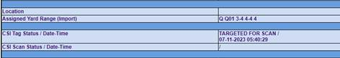

- Based on the email shown below, state if this container is for the purpose of Import or Export scanning?

  - __________________________
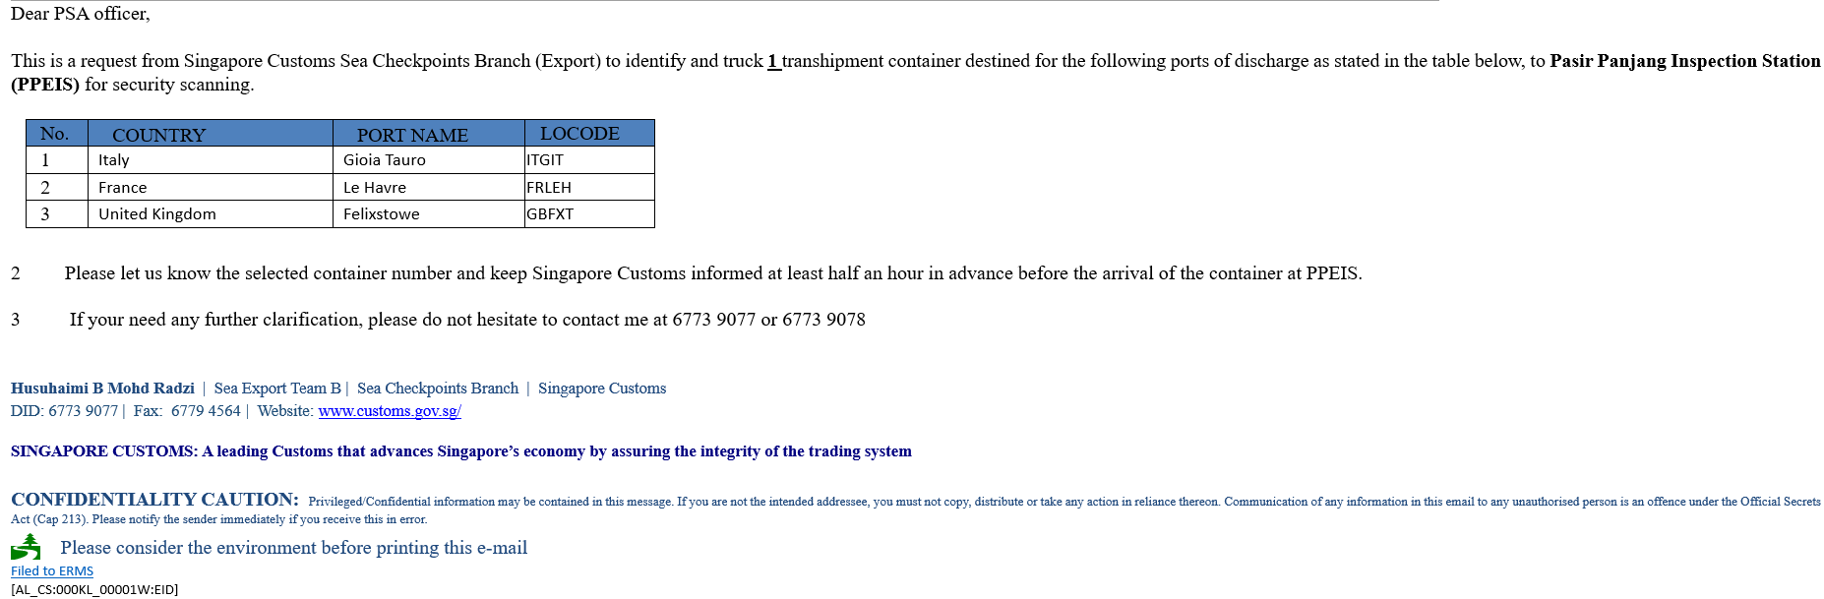
- Based on the information below, is this requested by ICA or Customs?

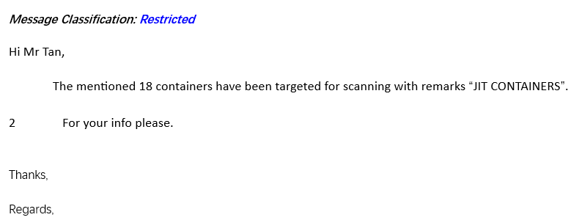
  - ___________________________________________________________

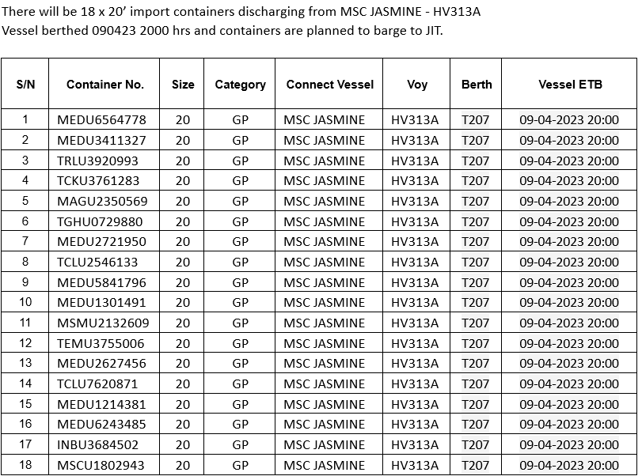

- Can a container with a jammed cone be shifted to J13 using a DST? Why?

  - _____________________________________________________________________________________________________________________________

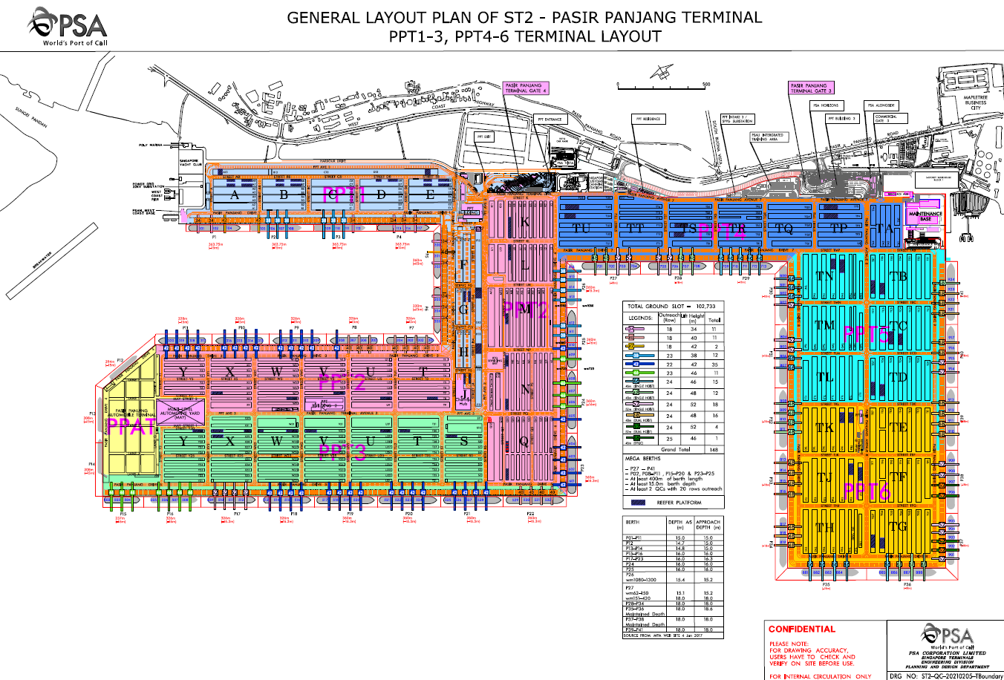
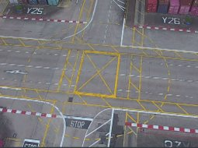

What zone is this?
____________________________

What area is this?
____________________________

MODULE 3 – DEPLOYMENT & RESOURCE ALLOCATION
Task | Tasks To Do | Task Objectives/Standard to Meet | Skills & Knowledge Explained | Checklist
Read Deployment Sheet | Verify DATE/SHIFT  Locate Total PM list in CT2IYS section  Locate Reefer PM list | Correct interpretation | - PPMXXX-YYYZZX = PM# + Driver ID  - Locate Total PM & Reefer PM lists in the system  - Verify DATE/SHIFT to ensure correct deployment sheet. | - Able to interpret information from deployment paper  - Verified DATE/SHIFT on deployment sheet  - Located Total PM list in CT2IYS.  - Located Reefer PM list in CT2IYS.  - Interpreted PM codes correctly (e.g., PPM023-DR456X = PM#23 + Driver DR456X).
Verify PM allocation/Reefer PMs | Count Total No. of PMs in list  Cross-check PMs with IYS pool panel | Ensure 100% tally between system records and physical PMs. | - Accuracy: Manually tally PMs in the list.  - Cross Reference: Compare IYS Pool Panel vs. physical PMs. | - Counted Total No. of PMs in the list.  - Cross-checked IYS Pool Panel for accuracy.  - Verified Reefer PMs (if applicable).  - Confirmed no mismatches in allocation.
Monitor PM logon | Check PM logon status  Account for PMs who did not logon  Follow up with CSO on PM status | Ensure 100% logon within 15 minutes of shift start. | - Real-Time Tracking: Monitor PM logon status in IYS system.  - Follow-Up Protocol: Contact CSO (Control Shift Officer) for missing logons.  - Problem-Solving: Resolve logon delays (e.g., system issues, miscommunication). | - Checked PM logon status in IYS.  - Accounted for PMs who did not logon.  - Followed up with CSO for missing logons.  - Ensured all PMs logged on within 15 mins.
Identify Discrepancies | Compare IYS deployment vs. physical PMs  Account for excess  Report for shortages | Report excess/shortages between system and physical PMs. | - Discrepancy Detection: Compare IYS deployment vs. physical PM count.  - Reporting Protocol: Escalate shortages/excess to CSO  - Root Cause Analysis: Investigate mismatches (e.g., wrong deployment, PM breakdowns). | - Compared IYS deployment vs. physical PMs.  - Accounted for excess PMs (if any).  - Reported shortages immediately.  - Documented discrepancies in shift log.

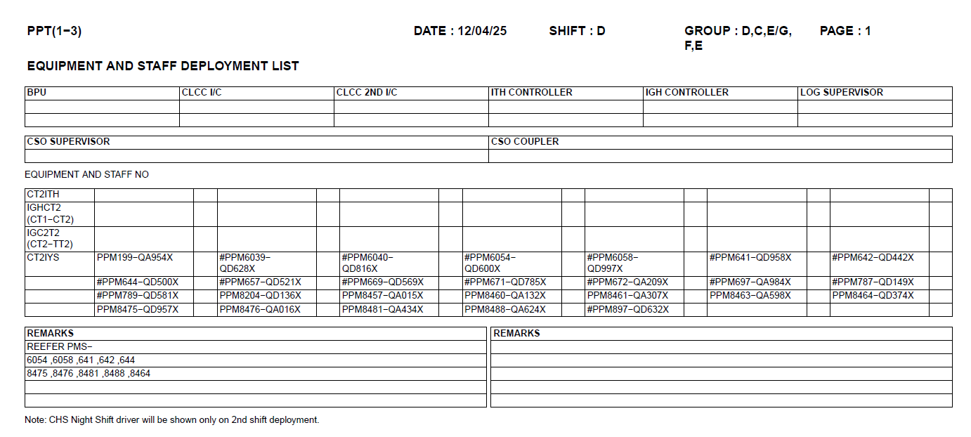

  - Based on this deployment sheet, how many PMs are deployed to reefer?

  - ___________________________________________________________________________

  - Based on this deployment sheet, how many DSTs are assigned to IYS?

  - ___________________________________________________________________________

MODULE 4 – CMRs, POINT GROUP & PM ALLOCATION
For each Point Group listed below for P1-3 (PG1-20) while P4-6 (PG1-12), write its primary purpose based on your observation and training.
Point Group | Reasons
1
2
3
4
5
6
11
12
13
14
15
16
17
18
19
20

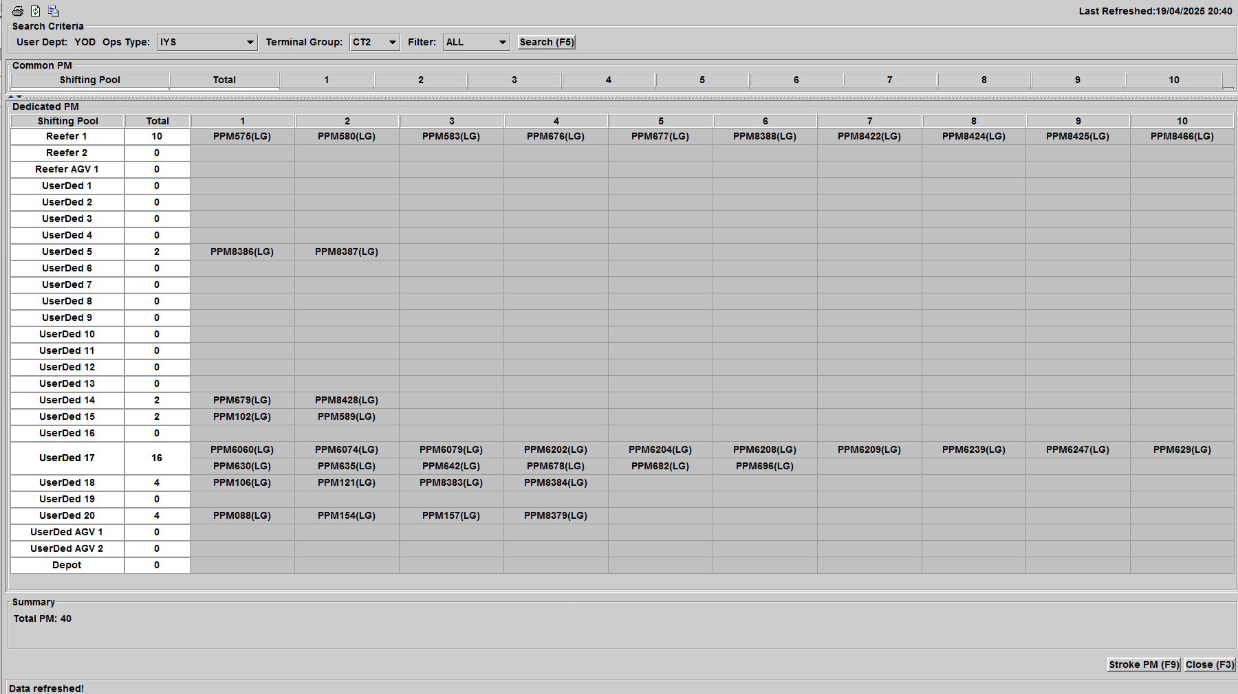
  - When was this data last refreshed?
□ 20:40 □ 30/04/2025 □ Both
Click the dropdown list under Terminal Group, select ‘CT3’ and the system will display the CT3 PM summary list

  - If you see "Total PM: 40" but only count 25 in the deployment list, what should you do?

□ Verify where the excess is from □ Undeploy all the excess PMs □ Both

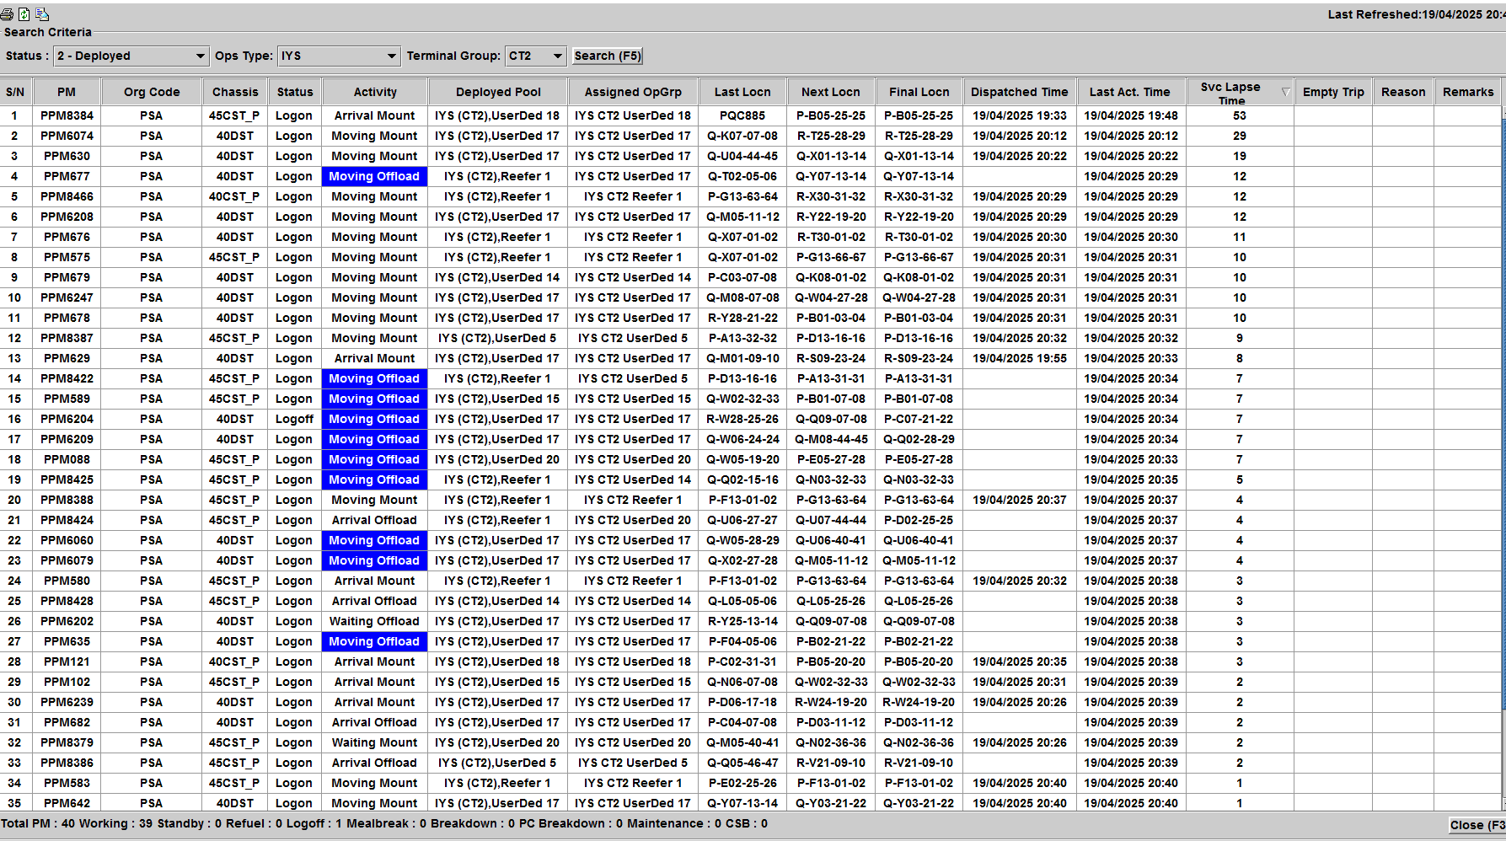
  - Total number of PMs deployed: ______________________________

  - Number of PMs on logoff:____________________________________

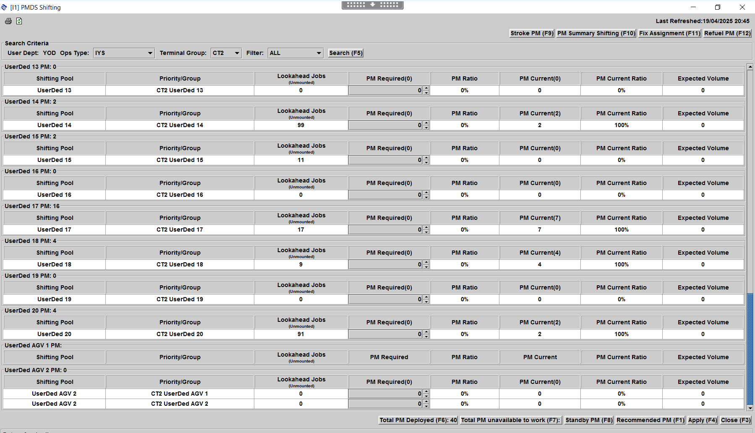

  - What does lookahead jobs mean? ________________________________________________________________________________

  - Which are the Point Groups with lookahead jobs? __________________________________________________________________

MODULE 5 – MONITOR YARC OPERATIONS & PM OPTIMIZATION

Write the key functions of each tab.
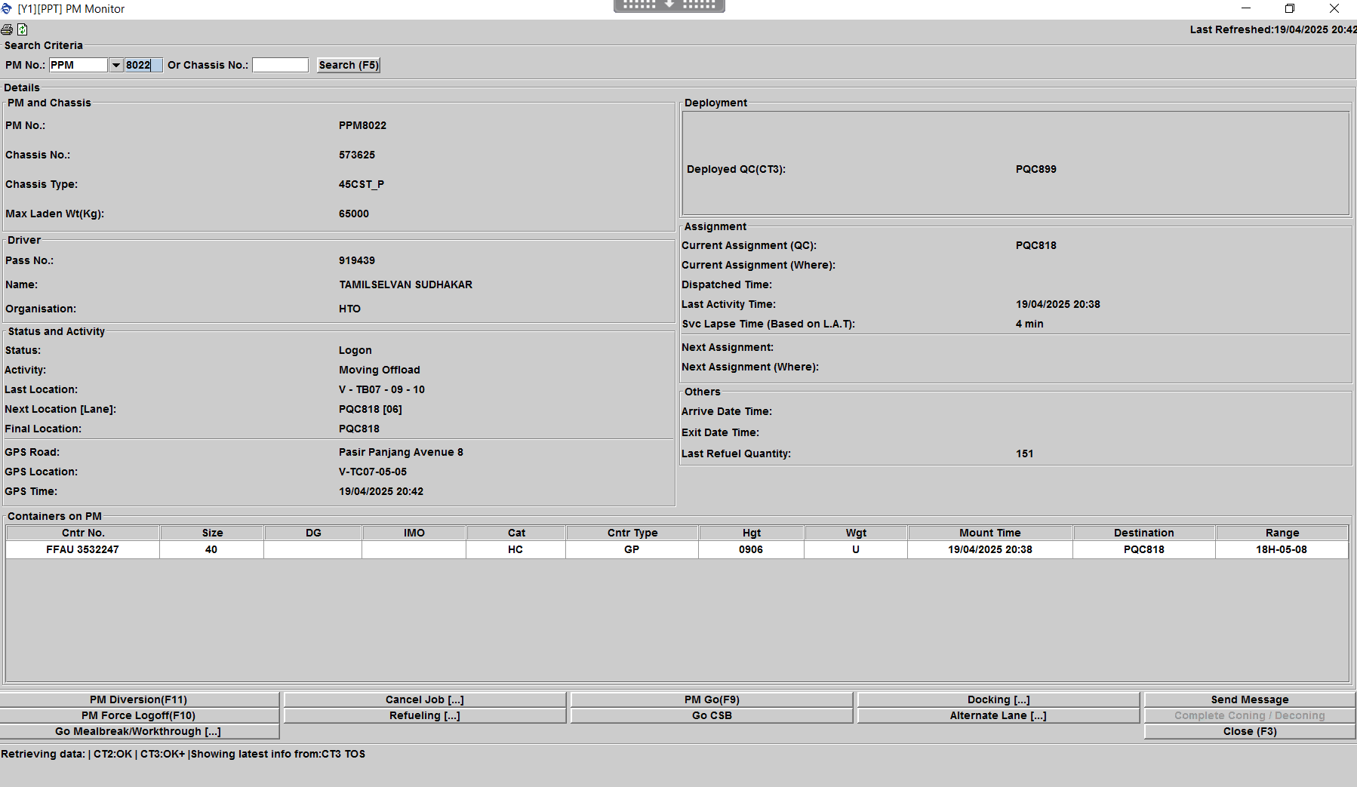

PM8022 called to inform his PC is on standby. List the steps on how to deploy PM8022 into IYS pool, PG20
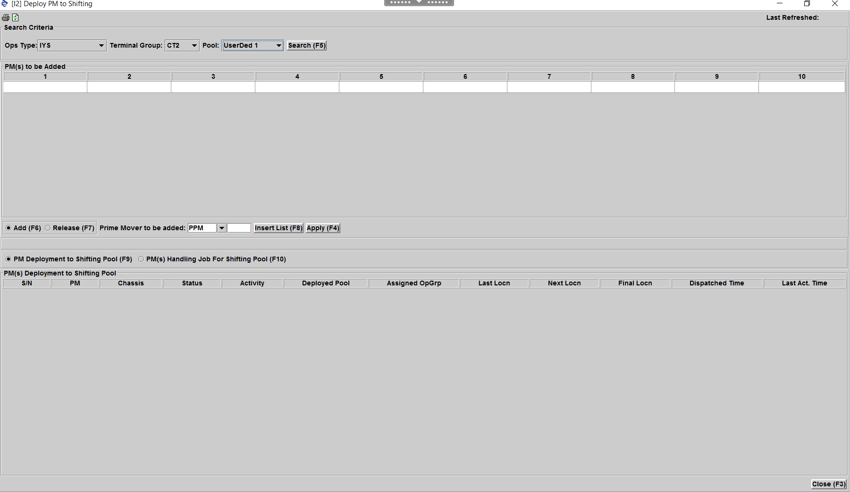
  - ___________________________________

  - ___________________________________

  - ___________________________________

  - ___________________________________

  - ___________________________________

  - ___________________________________

  - ___________________________________

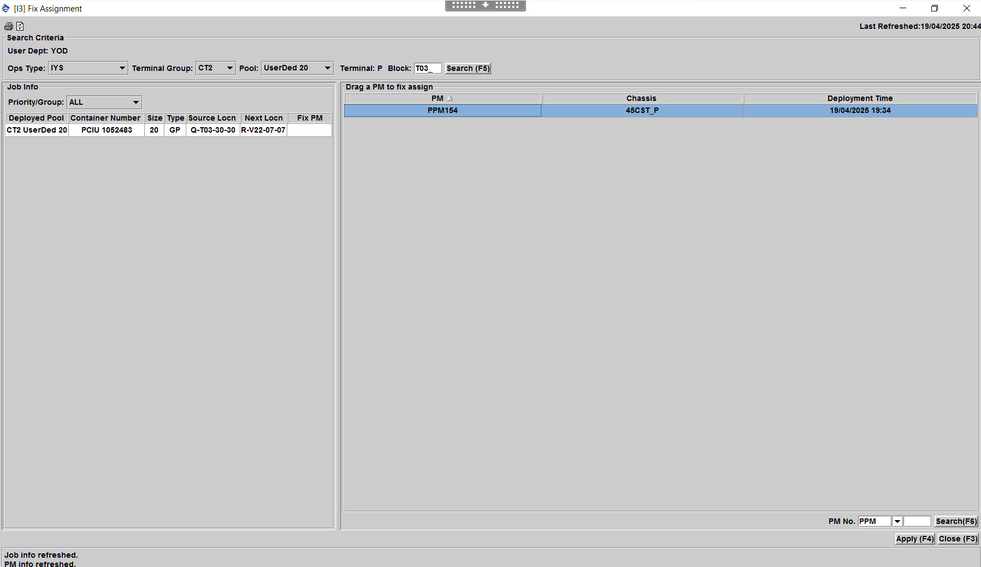

When do we utilize the Fix Assignment tool?
  - __________________________________________________________________________________________________________

MODULE 6 – HANDLE & ESCALATE DIFFERENT YARD EXCEPTIONS
This module helps you to identify, handle, and escalate various yard exceptions to maintain operational continuity and safety. You will learn protocols for common exceptions like misplaced containers, equipment failures, and hazardous situations.
Learning Objectives
✔ Recognize different types of yard exceptions
✔ Execute proper handling procedures
✔ Apply escalation protocols
✔ Document exceptions accurately
✔ Coordinate with relevant teams
Common Yard Exceptions & Handling Procedures
Exception Type | Escalation Protocols | Action To Be Taken | Others
Missing Container | YODM | - YODM will engage the YOCs to tally physical containers with PC location  - YODM to ENQC last known location  - YODM will escalate to respective terminals | To update correct location once container has been found
PM Breakdown | SRDO  CSO / PSO  YODM | - PM driver to notify SRDO  - YSS to check on status with SRDO after 15min of non-recovery  - If PM is unable to recover, check with CSO for alternative equipment for driver to take over  - Notify YODM if driver is put on standby due to no equipment | To be updated in YSS report
PM reported container on chassis leaking | YODM  YPDM | - Inform shift YODM of exception with container number, PM number and location  - Inform YPDM of exception | Ensure container is updated  Location to be given by YPDM  YODM to follow up with respective terminal
PM not deployed following shift | Nil | - Ensure PM is released 30-35min before shift end  - Ensure PM is on empty chassis | -
PM missing and uncontactable | Shift YODM  CSO / PSO | - Inform shift YODM & CSO, furnish info such as PM number, time uncontactable, duration uncontactable, last seen GPS location | Close loop once driver has been found  YODM to follow up with PMRD if needed
System/PC related issues | Shift YODM | - Inform shift YODM  - Take screenshots of issue (if any)  - Explain problem statement | Close loop once problem has been resolved

Competency Assessment Checklist for YSS
At the end of the first month of OJT, a mentor will be assigned to conduct the competency assessment to determine the current standing of the trainee. The mentor is responsible for assessing the trainee on the individual tasks and filling in the performance standards between a scale of 0 – 4.
1 – Need more practice, 2 –Pass, 3 – Good, 4 – Excellent
 | Task Outcome | Performance Standard |  |  |  | Mentor’s Comments
 | Task Outcome | 1 | 2 | 3 | 4
PERFORMANCE ASSESSMENT
1. | Perform Basic Terminal Operations and Monitor Yard Key Performance Indicators (KPI)
1. | Know Control Centre (CC) staff guidelines, different staff roles and contact list
1. | Know Basic Terminal Operations flow
1. | Know Yard KPIs and the tools to monitor them via  yard wait time excel and utilize PM NO SHOW panel
2. | Identify Yard Layout and Equipment
2. | Able to explain Yard Layout and Yard details
2. | Able to explain Yard Equipment and basic mode of operations
3. | Use of UHF set and CCTV for Operations
3. | Tune to YCO block channels
3. | Tune to IYS channels
3. | Private call numbers for PM/TT/RMG/FM
3. | Familiarize with own Section Yard CCTV numbers
4. | Use of Systems - (CITOS, YOMC) for Operations
4. | Familiar with CITOS functions
4. | Familiar with BPMS usage
4. | Familiar with use of CITIS functions
4. | YOMC – Understand all possible functions of and use to monitor yard operations
4. | VOMC - Understand vessel sequence and use  VPA to view incoming yard activities
5. | Gantry of RTGs and Yard Safety SOPs
5. | Ensure RTG gantry safely and correctly
5. | Understand Yard Safety SOPs
6. | Monitor Yard Operations, Equipment, and Operators
6. | Use YOMC to monitor IYS mounting/offloading
6. | Arrange for equipment parking and log on/off
6. | Update equipment fleet status
6. | Proper follow up with SR for breakdown
6. | Explain workings of ERTG/OHBC/RTG/FM/RMG and their differences
6. | Able to identify and evaluate PM performance
6. | Understand deployment sheet
6. | Plan for equipment mealbreak
7. | Forecast Yard Activities and Equipment Positioning
7. | Able to differentiate and use both YOMC job list and activity list
7. | Use VPA to forecast incoming activities
7. | Understand PM diversion SOP and Divert PMs correctly
8. | Handle and Escalate different Yard Exceptions
8. | Equipment breakdown
8. | Missing container/Wrongly updated container
8. | Leaking DG SOP
8. | Spillage in Yard and Bund SOP
8. | Reported Damaged containers
8. | Reported different containers in Yard/on PM
8. | Manual yard moves
SUPERVISORY SKILLS ASSESSMENT
9. | Manage Resources
9. | Knows the strategies and guidelines to achieve KPI targets
10. | Solve Problems and Make Decisions
10. | Identify relevant issues and causes of problems
10. | Make effective and practical decisions
10. | Show firmness and impartiality during course of work
10. | Explain the rationale behind work processes
11. | Manage and guide subordinates
11. | Provide guidance and corrections to PMs at work
ATTITUDE ASSESSMENT
12. | Provide Customer Service
12. | Answer to queries and able to direct to proper personnel involved
12. | Phone etiquette handling stakeholders
13. | Manage Job Performance
13. | Conscientious in execution of duties and responsibilities
13. | Willing and able to change his way of  working when required
13. | Willing to perform more than what is required of his assignment and job  without being told to do so

Verification by OJT Mentor / Competency Assessor

Name : Designation : Signature : Date : Comments :

Approved by SM (Ops)
Name : Designation : Signature : Date : Comments :

COMPETENCY ASSESSMENT SUMMARY (To be filled by mentor)

Competency 1: | Perform Basic Terminal Operations and Monitor Yard Key | C / NYC
 | Performance Indicators (KPI)
Competency 2: | Identify Yard Layout and Equipment | C / NYC
Competency 3: | Use of UHF set and CCTV for Operations | C / NYC
Competency 4: | Use of Systems - (CITOS, YOMC) for Operations | C / NYC
Competency 5: | PM Deployment & Yard Safety SOPs | C / NYC
Competency 6: | Monitor Yard Operations for YSS | C / NYC
Competency 7: | Forecast Yard Activities | C / NYC
Competency 8: | Handle and Escalate different Yard Exceptions | C / NYC
Competency 9: | Manage PM Resources | C / NYC
Competency 10: | Solve Problems and Make Decisions | C / NYC
Competency 11: | Manage and Guide Subordinates | C / NYC
Competency 12: | Provide Customer Service | C / NYC
Competency 13: | Manage Job Performance | C / NYC

The trainee is Competent / Not Yet Competent*
*delete if inapplicable.

If not yet competent
- Recommend for days of additional OJT training
- Recommend for full recourse of OJT training

OJT Mentor
Name : Designation : Signature :
Date : Comments :
General Competency Assessment Checklist for Assessor
Upon completion of the competency assessment, a Senior Officer will conduct the general competency assessment to determine if the trainee meets the required standards. The Senior Officer is responsible for assessing the trainee on the individual components and filling in the performance standards between a scale of 0 – 4. A trainee is required to attain a score of at least 3 for each component in order to pass the assessment
1 – Need more practice, 2 –Pass, 3 – Good, 4 – Excellent
 | Task Outcome | Competency Level |  |  |  | Comments
 | Task Outcome | 1 | 2 | 3 | 4
1 | Performance Assessment
1 | Grasp of YSS knowledge and requirements
1 | Application of job knowledge
1 | Timeliness in carrying out tasks
2 | Managerial Assessment
2 | Planning
2 | Organization of work
2 | Leadership
2 | Decision-making
2 | Communication
 | Overall YSS Rating

Verification by SM (Ops)

I hereby endorse that the trainee named
has fulfilled the requirements of the OJT components specified in this YSS Programmes.

Approved by SM (Ops)
Name : Designation : Signature : Date : Comments :

